AWS Systems Manager Parameter Store
Create and Retrieve Parameters Using Parameter Store
Introduction
Amazon Web Services AWS Systems Manager Parameter Store is used to securely store:
- Passwords
- API keys
- Database credentials
- Configuration values
- Environment variables
It helps applications securely access configuration data.

Architecture
Application → Parameter Store → Secure Parameters
Step1:open parameter store
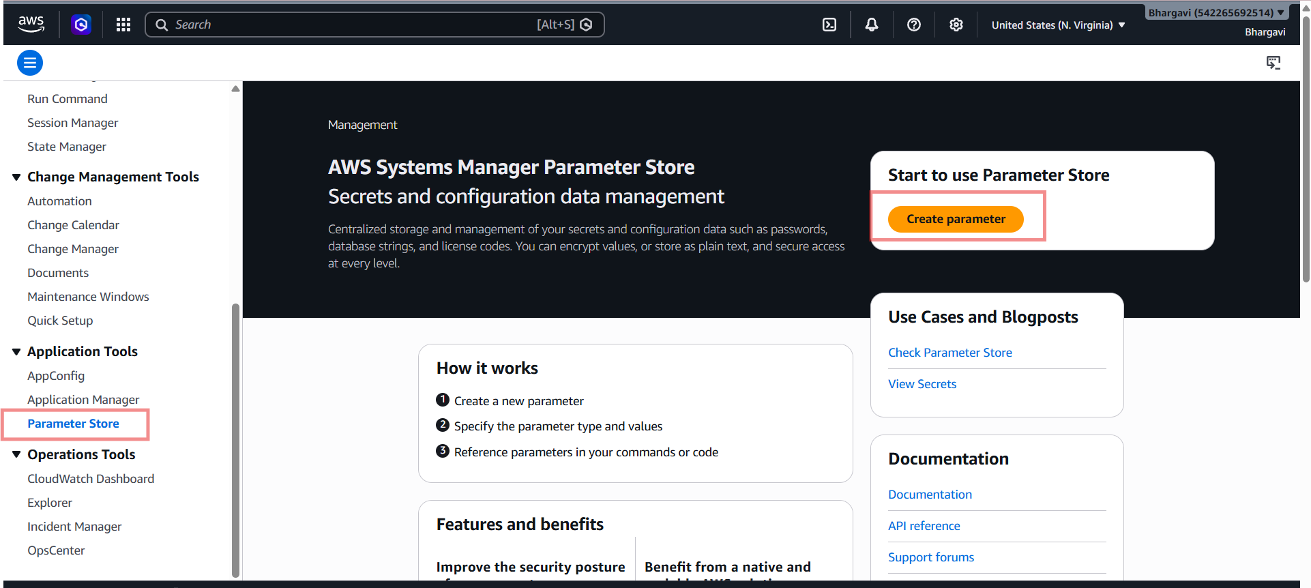
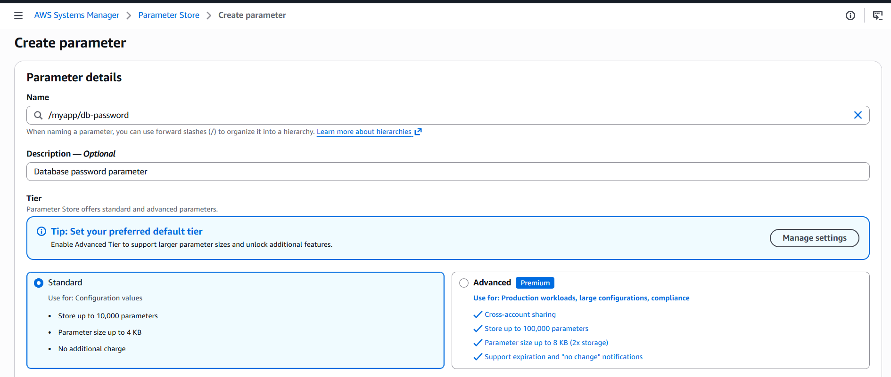
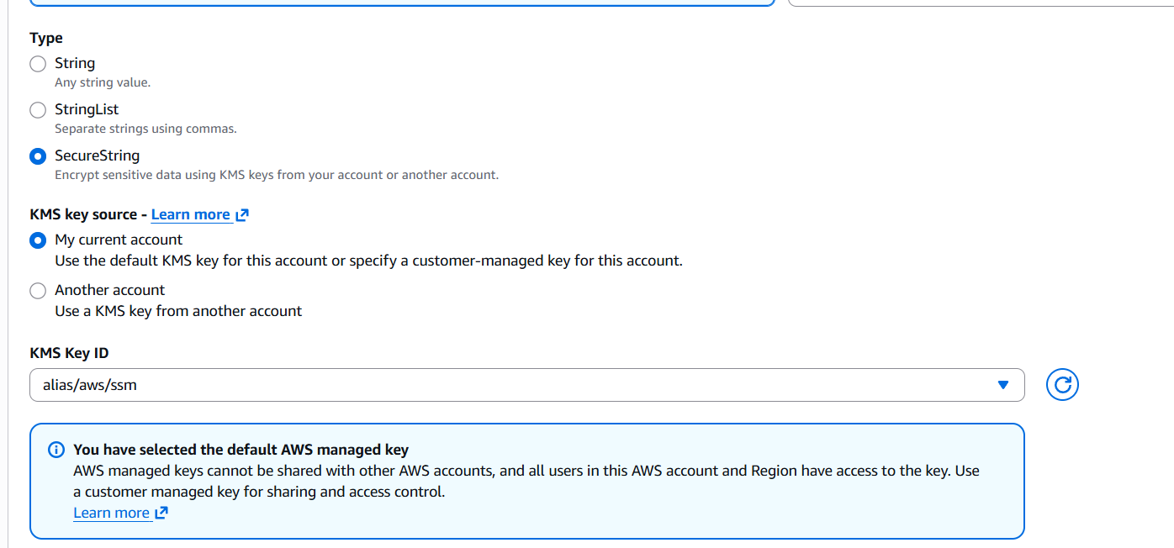
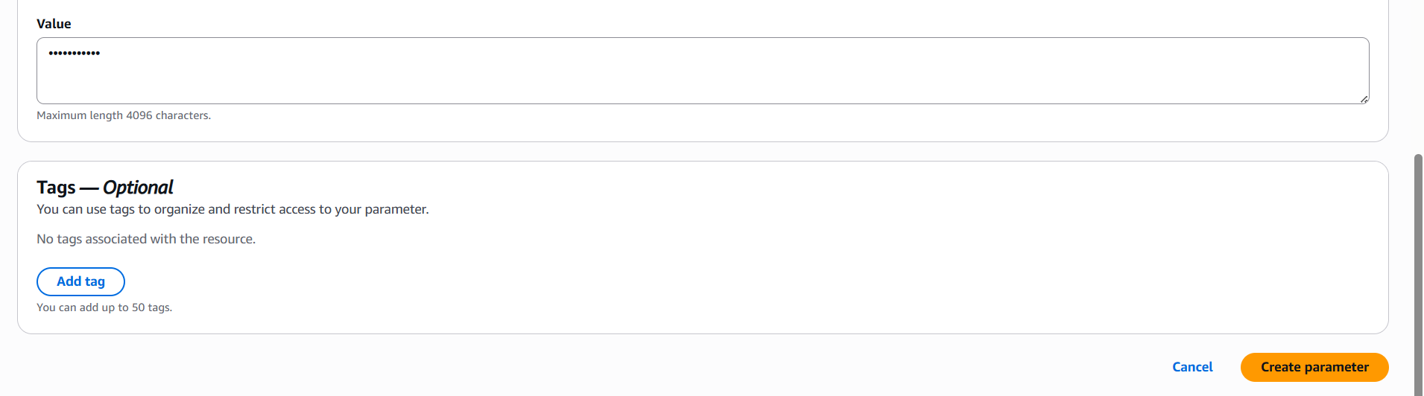
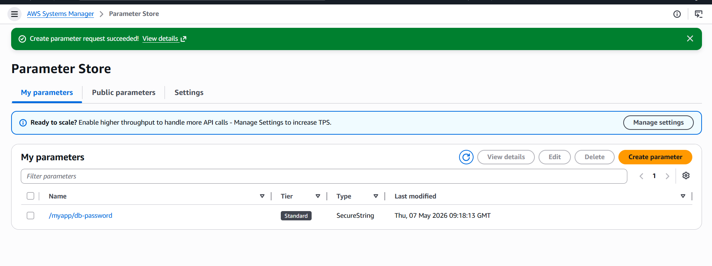
/myapp/db-password--Click parameter name.
Retrieve Parameter Value
Click:Show decrypted value
Now stored password becomes visible.
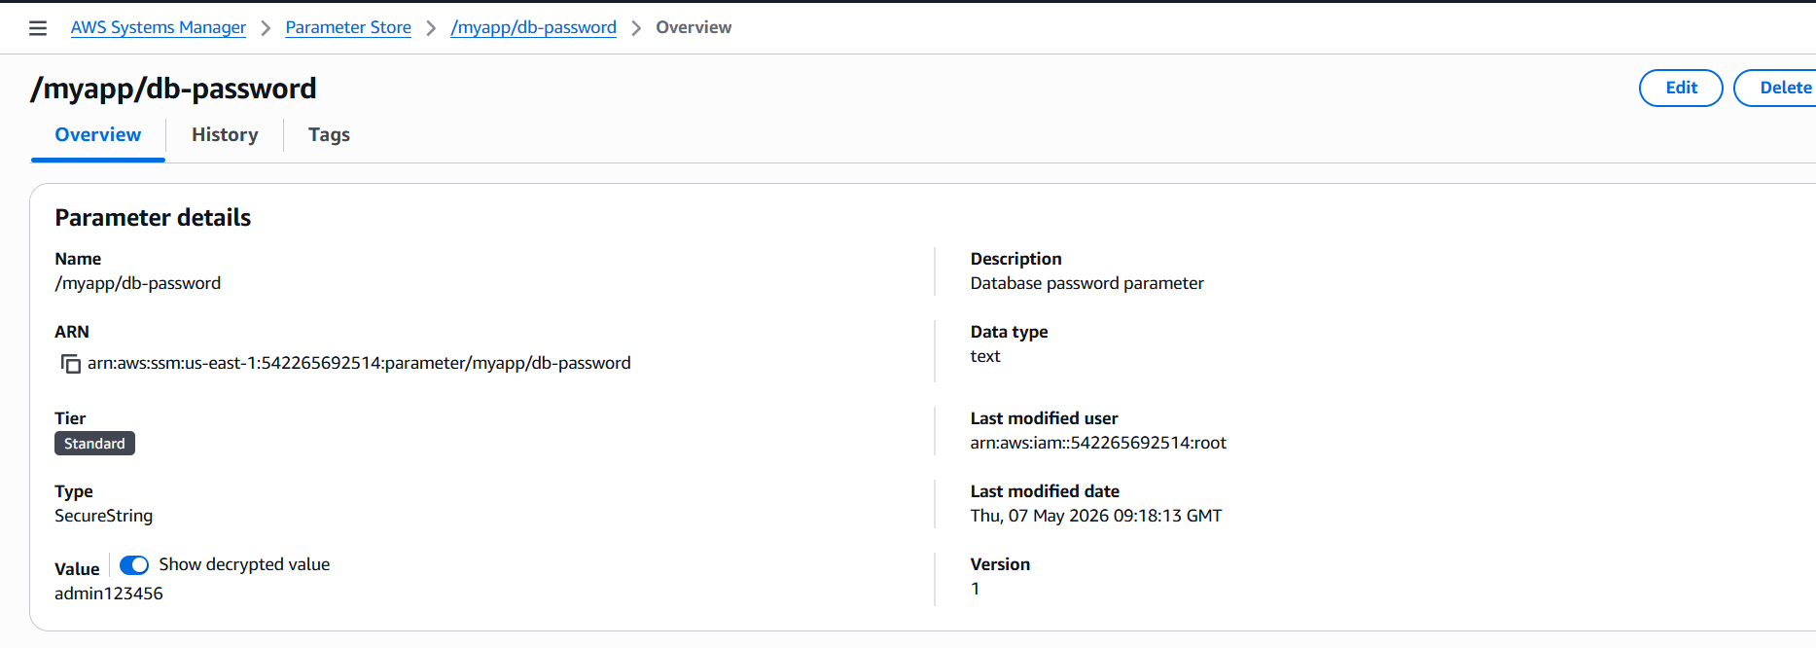
Verify Parameter Information
Verify:
- Parameter name
- Type
- Value
- KMS encryption
Now go to check:
Monitoring Parameter Store
Integrated with:
- CloudWatch
- CloudTrail
Used for:
- Access tracking
- Parameter retrieval monitoring
- Audit logging
- Open CloudTrail
- Search:
- CloudTrail
- Open:
- AWS CloudTrail
- Open Event History
- Click:
- Event history

Search Parameter Store Events
- In Event source enter:
- ssm.amazonaws.com
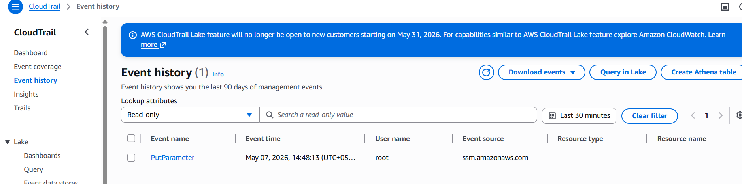
Example Architecture
Application → Parameter Store → KMS Encryption

Real-Time Use Case
Application Database Credentials
Application → Parameter Store → Database Password
Applications retrieve passwords securely instead of storing them inside code.

Advantages of Parameter Store
Secure parameter storage
KMS encryption
IAM access control
Centralized management
CloudTrail monitoring
Output Verification
Successfully:
- Created parameter
- Stored encrypted password
- Retrieved parameter securely
- Verified monitoring logs

Conclusion
AWS Systems Manager Parameter Store securely stores application configuration values and sensitive information using encryption and centralized management. It improves application security and simplifies configuration handling in AWS environments.

